Table 1 Policy Name and Information
 | Student Preferred Name Policy
  Policy #: | SA004.1
  Policy Type: | University
  Responsible Executive: | VPSA
  Responsible Office: | OSSA
  Originally Issued: | September 4, 2024
  Latest Revision: | September 4, 2024
  Effective Date: | September 4, 2024

Policy Statement
The University of Louisiana Monroe (ULM) Student Preferred Name Policy allows students to choose a preferred name for use within ULM systems. While the university strives to implement this policy as broadly as possible, there may be instances where the legal name must be used due to legal, technical, or administrative requirements.

Purpose of Policy
ULM recognizes that many of its students use first names other than their legal (primary) first names to identify themselves. It is the policy of ULM that any student may choose to identify within the University community with a preferred first name that differs from their legal name. The preferred first name will appear in university related systems and documents except where the use of the legal name is necessitated or required by law or University business needs. Systems that do not require legal names will be updated to use preferred names as they are reconfigured or newly implemented.

Applicability
This policy applies to ULM Students.

Definitions
Preferred Name: A name that a person chooses to be called that is different from their legal name. This name may reflect an individual's gender identity, cultural background, or personal preference.

Legal Name: The name that is listed on an individual’s official identification documents, such as a birth certificate, passport, driver’s license, or social security card. This name is typically used for legal, administrative, and financial purposes.

Students: Individuals who are currently enrolled in any course or program at the university, including undergraduate, graduate, and professional students, whether they are attending full-time or part-time.

Policy Procedure
Preferred Name Guidelines
- A preferred name should be the name the student commonly uses.
- Preferred names must be composed of letters only; no numbers or symbols may be used (except for a hyphen, apostrophe or period.)
- Preferred names may not contain inappropriate or offensive language.
- Preferred names may not be used for misrepresentation or any illegal purpose.
- All determinations regarding the appropriateness of a preferred name are made at the discretion of the Division of Student Affairs, which will communicate its decision to the student.
- The Division of Student Affairs will regularly audit preferred names to ensure they are appropriate and enforce the limit on the number of changes a student can make.
- Inappropriate use of a preferred name will result in the reversal of the preferred name request and may lead to disciplinary action if it violates another ULM policy.

Procedures
- Students are encouraged to add/update their preferred name before a term begins to avoid confusion. If students add or modify their preferred name, especially during the term, the student remains responsible for updating those who need to be aware of the update.
- Students are limited to adding/updating a preferred name three times during their time at ULM.
- To establish a preferred name, students must submit a request via the following webform Link to Student Preferred Name Request Form
Usage
- Details regarding the specific instances where a legal name will continue to be used and where a preferred name will be applied can be found on the ULM Division of Student Affairs website. Please visit Link to Student Affairs Name Policy for comprehensive information on this policy.
Appeal
- If a preferred name request is denied, the student will be notified and may submit an email appeal to preferredname@ulm.edu

Enforcement
The Vice President for Student Affairs is responsible for the enforcement of this policy.

Policy Management
The Vice President for Student Affairs is the Responsible Executive for the management of this Policy. The Director of Student Advocacy and Accountability is the Responsible Officer in charge of implementing and administering the Policy. The Office of Student Advocacy and Accountability (OSSA) will implement and administer the policy.

Limitations
The university will make every reasonable effort to use preferred names as requested, within the constraints outlined below.
- No Change to Legal Name: The use of a preferred name in university systems does not constitute a legal name change. The student’s legal name will continue to be used in all instances where it is required by law, regulation, or university policy. To change a legal name, students must complete a Name Change Request, bring the completed form, original Social Security Card and photo ID to the Office of the Registrar.

- Awareness and Usage by Faculty and Staff: The University cannot guarantee that all faculty and staff will be aware of or use a student's preferred name at all times. Students should be prepared to communicate their preferred name directly to their instructors, advisors, and university personnel.
- Limitations Across University Systems: The use of preferred names may not apply across all university systems or records due to technical limitations or legal requirements. Some university systems are required to use a student’s legal name for compliance with federal, state, or local laws, or for administrative and operational purposes.

Effective Date
This Policy will become effective upon the date signed by the University President.

Adoption
This policy is hereby adopted on this 4th day of September 2024.
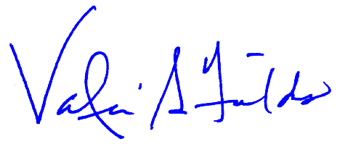
Recommended for Approval by: Approved by:
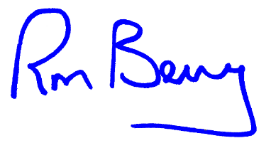
____________________________________ ____________________________________
Dr. Valerie Fields, VP for Student Affairs Dr. Ronald L. Berry, President

Appendices, References and Related Materials
Students seeking to change their legal name must complete the Name Change Request Form administered by the Office of the Registrar.

Revision History
Original adoption date: September 4, 2024.

