 | Undergraduate Course Repeat and Repair Policy
  Policy #: | AA020.1.
  Policy Type: | University
  Responsible Executive: | Provost
  Responsible Office: | Academic Affairs
  Originally Issued: | June 25, 2024
  Latest Revision: | June 25, 2024
  Effective Date: | July 1, 2024

I. Policy Statement
At times, students need to demonstrate higher mastery in courses they have previously taken. This improvement should be reflected in their graduation GPA. However, this allowance should be regulated as to assure adequate progress toward degree.

II. Purpose of Policy
The Undergraduate Course Repeat and Repair Policy allows for the limited replacement of undergraduate academic credit with higher marks for the same course in the calculation of the student’s graduation GPA.

III. Applicability
This policy applies to all undergraduate courses taught at ULM.

IV. Definitions
NA

V. Policy Procedure
Parameters:
- This policy can be applied only once per course.
- This policy does not apply to courses counted in a previously awarded degree or to graduate courses.
- This policy can be applied to a maximum of twelve (12) credit hours and 4 courses.
- This policy cannot be applied to courses in which the final grade was awarded for academic dishonesty.
- This policy only applies to the first time a course is repeated.
- If a course is repeated after the Repeat/Repair option has been applied, then all courses, except the first grade, will be used in the calculation of the graduation GPA.
- Repeat/Repair cannot change the notation of academic standing.
- The grade of the repetition will be used in the calculation of the graduation GPA, regardless of if it is higher, lower, or the same as the original grade.
- The initial grade will remain on the transcript but not used in determining the graduation GPA. It may be used by employers, professional schools, and graduate schools for their respective purposes.
To initiate the process, students must request the Repeat/Repair option through their advisor before the expiration of the course withdrawal period for the semester in which the course is first repeated.

VI. Enforcement
The Provost, deans, and Registrar are responsible for the enforcement of this policy.

VII. Policy Management
The Provost will be the Responsible Executive for the management of this policy. The Provost or his/her designee will be the Responsible Officer in charge of maintaining and disseminating it.

VIII. Exclusions
None.

IX. Effective Date
This Policy will become effective on July 1, 2024.

X. Adoption
This policy is hereby adopted on this 25th day of June 2024.
Recommended for Approval by: Approved by:
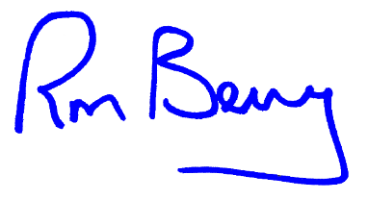
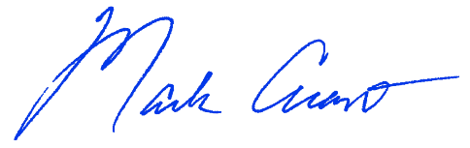
____________________________________ ____________________________________
Dr. Mark Arant, Provost Dr. Ronald L. Berry, President

XI. Appendices, References and Related Materials

XII. Revision History
Original Adoption Date: June 25, 2024.

