 | Repeat Course Policy
  Policy #: | AA019.1
  Policy Type: | University
  Responsible Executive: | Provost & VPAA
  Responsible Office: | Academic Affairs
  Originally Issued: | June 25, 2024
  Latest Revision: | June 25, 2024
  Effective Date: | July 1, 2024

I. Policy Statement
The Repeat Course Policy determines when and how undergraduate students can retake courses at ULM for grades.

II. Purpose of Policy
Degree programs are designed for students to build upon content and skills introduced in lower-level courses. Curricula provide streams of progress resulting in degree completion. To assure progress toward the degree and avoid potential academic, graduation, and financial difficulties, the number of times that courses are repeated must be regulated. While it is necessary that courses must be repeated to meet degree requirements, retaking classes to improve grade point averages or other non-matriculation reasons has the potential to cause unintended harm. This policy provides direction on when retaking classes is appropriate and how approvals are obtained for the repetition.

III. Applicability
This policy is applicable to undergraduate students and to all courses in which a student has received an “A”, “B”, “C”, or “D”, as these are considered as passing grades. This policy does not apply to graduate students or to courses receiving other grade notations unless that notation is governed by another university policy.

IV. Definitions
N/A

V. Policy Procedure
Any student receiving a passing grade for a class may not retake the class unless:
- The course is an independent study, independent research, or internship course, or has variable topics. Course descriptions will dictate the number of times and hours that these courses can be repeated.
- The subsequent course requires a higher letter grade to matriculate. The student’s advisor’s permission is required to register for the course again.
- The degree program requires a higher letter grade to matriculate. The permission of the student’s advisor and the program’s dean must be obtained to register for the course again.
- The student petitions their academic dean with appropriate justification. In this case, the student must get permission from the student’s advisor, their dean, and the dean over the course.
A course can be repeated a maximum of three times. It should be noted that some programs may be more restrictive, allowing fewer repeats. No program will allow for more than three.
Withdrawals (indicated by a “W”) do not count toward the attempts. Courses repeated must be the exact course, and students may not use substitutions for repeated courses. Prior permission from the student’s dean must be obtained to transfer the course to ULM from another institution. Each transfer is counted as an attempt.
All students repeating a course must check with their financial aid counselor to see how the repeated course will affect their scholarships and aid. Proof that the financial aid counselor has been consulted is expected as part of the request for permission. The appropriate school director and dean will determine the application of the repeat course policy in those instances where course numbers and/or titles have been changed at ULM.
When a student repeats a course, the last grade earned will be counted in computing the grade point average for undergraduate degree requirements and for graduation. However, all grades from all attempts remain on the student’s transcript and are used in computing the cumulative average and for honors and admission to professional schools.

VI. Enforcement
This policy will be enforced by the Office of Academic Affairs and the deans of the colleges.

VII. Policy Management
The Provost is the executive responsible for this policy, while the Office of the Registrar implements and administers the policy.

VIII. Exclusions
N/A

IX. Effective Date
This policy will become effective July 1, 2024.

X. Adoption
This policy is hereby adopted on this 25th day of June 2024.
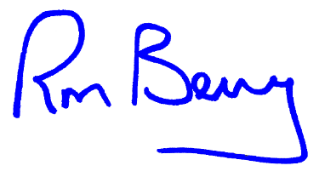
Recommended for Approval by: Approved by:
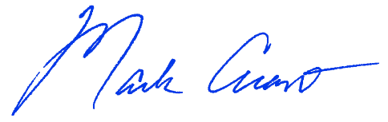
____________________________________ ____________________________________
Dr. Mark Arant, Provost Dr. Ronald L. Berry, President

XI. Appendices, References and Related Materials
ULM Undergraduate Catalog - Link to the ULM Undergraduate Catalog

XII. Revision History
Original Adoption Date: June 25, 2024

