 | Hiring Faculty With Remaining Dissertation Requirements Policy
  Policy #: | AA009.1
  Policy Type: | University
  Responsible Executive: | Provost
  Responsible Office: | VPAA
  Originally Issued: | June 25, 2024
  Latest Revision: | June 25, 2024
  Effective Date: | July 1, 2024

I. Policy Statement
Most faculty positions at a university will require possession of a terminal or advanced degree. Due to the timing of the search, some hiring decisions are made on tenure-track lines before the future faculty member has received the expected degree. This policy covers how hiring will proceed when the successful candidate has remaining degree requirements that should be fulfilled.

II. Purpose of Policy
Opportunities arise during hiring processes to add outstanding faculty that are completing degree requirements. These candidates show promise and potential to contribute to the advancement of the program and university. However, the tenure and tenure-track faculty ranks require specific requirements, e.g., terminal degrees, to maintain their quality and integrity. To preserve that system, those new colleagues that are completing the expected requirements, should not enter the professoriate on a tenure or tenure-track status.
The absence of such a degree being awarded by the first day of employment, however, should not preclude the individual from starting work at ULM. If the only impediment to starting in the tenure-track position is completion of the dissertation, the faculty member can be hired temporarily with non-tenure track status with a deadline by which the requirements must be completed. Once the degree is conferred, the faculty member’s contract will be amended to reflect the change of tenure-track status and rank, if necessary.

III. Applicability
This policy and the associated procedures apply to all faculty being hired on a tenure-track line.

IV. Definitions

V. Policy Procedure
When a new faculty member without the completed credentials is hired, their contract will be written to reflect a non-tenure track status, unless prior written approval has been obtained for a tenure-track position from the Vice President for Academic Affairs. Besides the normal language in the contract about working at ULM, the following should be stated:
- The credentials must be conferred within one calendar year of the first employment date. In unusual and extreme cases, this deadline can be extended beyond one year with approval of the Dean and Provost. Failure to secure the degree by the deadline will result in the following year’s contract being a terminal one.
- Until the degree is awarded, the faculty member will be hired and paid at a pay rate of the rank awarded.
- The first year can count toward the tenure probationary period for the faculty member. This will be negotiated upon hire and reflected in the offer letter and contract.

VI. Enforcement
The Provost and Director of Human Resources are responsible for the enforcement of this policy.

VII. Policy Management
The Provost will be the Responsible Executive for the management of this Policy. The Provost or his/her designee will be the Responsible Officer in charge of maintaining and disseminating it.

VIII. Exclusions
None.

IX. Effective Date
This Policy will become on July 1, 2024.

X. Adoption
This policy is hereby adopted on this 25th day of June 2024.
Recommended for Approval by: Approved by:
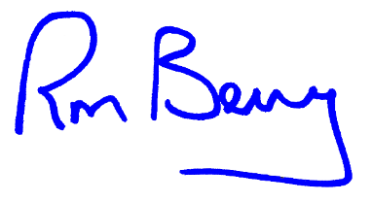
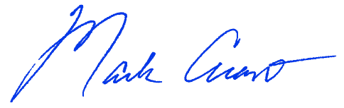
____________________________________ ____________________________________
Dr. Mark Arant, Provost Dr. Ronald L. Berry, President

XI. Appendices, References and Related Materials
N/A.

XII. Revision History
Original Adoption Date: June 25, 2024.

