 | Accelerated Bachelors-to-Masters Policy
  Policy #: | AA007.1
  Policy Type: | Academic Affairs
  Responsible Executive: | Provost
  Responsible Office: | VPAA
  Originally Issued: | October 18, 2023
  Latest Revision: | October 18, 2023
  Effective Date: | October 18, 2023

Policy Statement
The Accelerated Bachelors-to-Masters Policy creates the conditions under which an accelerated bachelors-to-masters (ABM) program can be offered to students.

II. Purpose of Policy
This purpose of this policy is to outline the conditions in which an ABM program can be offered at the University of Louisiana Monroe. Prior to 2020, undergraduate students at institutions within the University of Louisiana System were allowed to take graduate-level courses if they were within 30 hours of graduating and had a good GPA; however, this coursework only applied to any future graduate program into which they enrolled and could not count toward their undergraduate degree. In late 2019, this ULS policy changed to allow up to 12 hours of coursework to count in both undergraduate and graduate degree programs: Link to ULS Policy, Chapter Two, Section IX.E.4.
In making this change, the ULS has created a system whereby high-achieving undergraduate students have the opportunity to complete both a bachelor’s and master’s degree within a five-year time period instead of the normal six. This path will allow them to start their career earlier with an advanced degree and with reduced expenses and debt, as this accelerated program will eliminate one year of tuition and fees. This will greatly increase their chances of career success, in line with ULM’s Strategic Plan.

III. Applicability
This policy will apply to any undergraduate student who meets the requirements for entry into an ABM program and will be pursuing a graduate degree in a program that has adopted the ABM model.

IV. Definitions
Accelerated Bachelors-to-Masters (ABM) program – a collaboration between an undergraduate degree program and a graduate degree program that has been approved to accept graduate-level course credit in both programs.

V. Policy Procedure
Per ULS policy, before students can begin their studies in an ABM program, the faculty who offer the bachelor’s and master’s degree programs in which the student is seeking to complete coursework must approve the acceptance of the graduate coursework in both programs.

Besides the fact that the group of graduate faculty who offer the master’s degree are often different from the group who offer the undergraduate degree within the same discipline (not all faculty in a discipline are graduate faculty), the interdisciplinary nature of some programs means that it is possible for graduate faculty approving an ABM master’s degree program to be in a different school or college from the faculty approving the undergraduate portion of an ABM program.

Before any student is allowed to start in an ABM program, both sets of faculty will need to get approval for their portion of the ABM program through the proper curriculum review process (see attachment; this will later become a link to the form online).
Once the ABM program has been approved, undergraduate students who meet the proper qualifications for the program may begin taking graduate coursework. These qualifications are:
- The student must be within 30 hours of completing the undergraduate portion of the ABM program.
- The student must have a 3.2 GPA on all undergraduate coursework.
- The undergraduate student must be provisionally admitted to the Graduate School and the graduate portion of the ABM program.

The student will need to maintain a 3.0 GPA while completing the requirements for the bachelor’s degree. Failure to do so will result in the student being removed from the ABM program at the end of the semester after which the GPA has gone below a 3.0. Any graduate courses taken up to the point will count toward the undergraduate coursework, but the student will no longer be able to take graduate courses until after they have completed their bachelor’s degree and been fully admitted into the Graduate School.

VI. Enforcement
The Provost is the responsible party for the enforcement of this policy. The responsibility for insuring that students remain viable in the program falls to the dean of the college in which the undergraduate program is housed.

VII. Policy Management
The Provost will be the Responsible Executive for the management of this Policy. The Provost or his/her designee will be the Responsible Officer in charge of maintaining and disseminating it. The college deans and the Dean of the Graduate School are the responsible parties for implementing the policy.

VIII. Exclusions
None.

IX. Effective Date
This Policy will become effective upon the date signed by the University President.

X. Adoption
This policy is hereby adopted on this 18th day of October 2023.
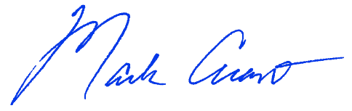
Recommended for Approval by: Approved by:
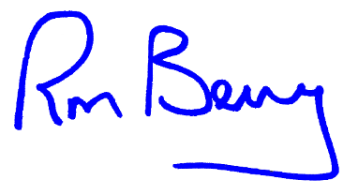
____________________________________ ____________________________________
Dr. Mark Arant, Provost Dr. Ronald L. Berry, President

XI. Appendices, References and Related Materials
ULS Policy, Part Two, Admission to Graduate Study : Link to ULS Policy, Chapter Two, Section IX.E.4

ABM Degree Approval Form: See Attachment (when approved, this will become a link to the form on the web)

XII. Revision History
Original adoption date: October 18, 2023

