 | Attendance Reporting Policy
  Policy #: | AA017.1
  Policy Type: | University
  Responsible Executive: | Provost
  Responsible Office: | Academic Affairs
  Originally Issued: | June 25, 2024
  Latest Revision: | June 25, 2024
  Effective Date: | July 1, 2024

I. Policy Statement
The Attendance Reporting Policy will allow ULM to comply with federal financial aid regulations regarding student attendance and participation in classes. It outlines the requirement for faculty members to take attendance of students between the start of the session and the official census date and report students who have not attended class to the respective department or college administration. Doing this will ensure compliance with federal and state regulations governing the disbursement and maintenance of financial aid for eligible students and promote transparency and accountability in tracking student attendance. This policy supports the enforcement of the attendance policies in the Undergraduate and Graduate Catalogs.

II. Purpose of Policy
Federal financial aid regulations require students who receive this type of aid to attend and actively participate in all classes for which they are enrolled. As an accredited institution that can award such aid, ULM is required to ensure that all its students comply with these regulations. This policy will require all faculty to report non-attendance by students during the period before the official census date. Students who have not attended class during this period will be removed from the class and reported to the ULM Financial Aid Office.

III. Applicability
This policy applies to all faculty members who are teaching at ULM.

IV. Definitions
N/A

V. Policy Procedure
Requirements
Per ULM policies, faculty will take regular attendance and will follow all policies regarding reporting of attendance. This is especially important prior to the official census date. Attendance records must be accurate, and faculty members should use a university-approved method or system for recording attendance, which may include electronic attendance tracking tools or manual record-keeping. In cases where a class is held online or in a hybrid format, faculty members are responsible for implementing appropriate methods to monitor and document student participation.
Reporting Non-Attendance
If a student does not attend class during the period prior to census without communication to the instructor with valid reasons (e.g., medical issues, family emergencies) for the absence, the faculty member must report the absences to the associate dean of the college to have the student administratively removed from the class.
This information will also be communicated by the dean’s office to the ULM Financial Aid Office. Students added late to the roster should not be penalized for non-attendance prior to enrollment.

Financial Aid Office Responsibilities
The Financial Aid Office shall use the information provided by faculty members to identify students who may be at risk of not meeting attendance requirements for financial aid eligibility. These students who are at risk of losing financial aid due to non-attendance will be notified and informed of the consequences and the steps they need to take to regain eligibility.

Student Support and Notification
Students who receive notifications from the Financial Aid Office due to non-attendance will be directed to academic advisors and support services to address any challenges they may be facing.

Confidentiality
All attendance records and reports related to student non-attendance shall be treated as confidential information and handled in accordance with applicable privacy laws and university policies.

Compliance and Enforcement
Faculty members are expected to comply with this attendance reporting policy as a standard part of their responsibilities. Failure to adhere to this policy may result in appropriate disciplinary actions as determined by the University.

VI. Enforcement
The Office of Academic Affairs, deans, and Director of Financial Aid are responsible for enforcing this policy.

VII. Policy Management
The Provost will be the Responsible Executive for the management of this Policy. The Provost or his/her designee will be the Responsible Officer in charge of maintaining and disseminating it.

VIII. Exclusions
None.

IX. Effective Date
This Policy will become effective on the July 1, 2024.

X. Adoption
This policy is hereby adopted on this 25th day of June 2024.
Recommended for Approval by: Approved by:
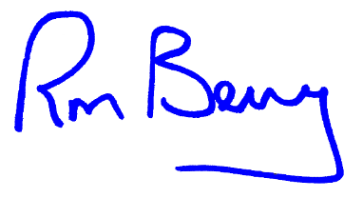
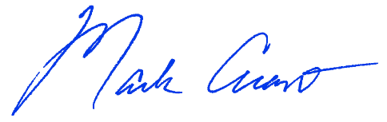
____________________________________ ____________________________________
Dr. Mark Arant, Provost Dr. Ronald L. Berry, President

XI. Appendices, References and Related Materials
N/A.

XII. Revision History
Original Adoption Date: June 25, 2024

