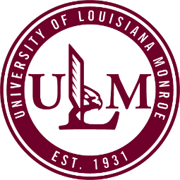 | Verification of Institutional and Program Accreditation Status Policy
  Policy #: | AA011.1
  Policy Type: | University
  Responsible Executive: | VP for Academic Affairs
  Responsible Office: | Academic Affairs
  Originally Issued: | March 19, 2019
  Latest Revision: | March 19, 2019
  Effective Date: | March 19, 2019

Policy Statement
The University of Louisiana at Monroe’s (ULM) Verification of Institutional and Program Accreditation Status Policy establishes the procedures for verifying institutional and program accreditation status and notifying SACSCOC and specialized or professional accreditation agencies when there is any type of change in accreditation status.

II. Purpose of Policy
ULM must inform SACSCOC and specialized or professional accreditation agencies when there is any type of change in accreditation status.
ULM’s Verification of Institutional and Program Accreditation Status Policy establishes the procedures for verifying institutional and program accreditation status and notifying SACSCOC and specialized or professional accreditation agencies when there is any type of change in accreditation status.

III. Applicability
This policy applies to ULM’s academic programs.

IV. Definitions
- Accreditation: ULM and many of its colleges, schools, departments, and programs which make up the university are accredited by specialized or professional accreditation agencies.

V. Policy Procedure
ULM has institutional and program specific accreditations. The program specific accreditation agencies are listed below.
ACCREDITATION AGENCIES
- Accounting program is accredited by AACSB International, the Association to Advance Collegiate Schools of Business.
- Business programs in the College of Business and Social Sciences are accredited by AACSB International, the Association to Advance Collegiate Schools of Business.
- Computer Science program in the College of Business and Social Sciences is accredited by the Computer Accreditation Commission of the Computing Sciences Accrediting Board for Engineering and Technology (ABET).
- Construction Management program is accredited by the American Council for Construction Education.
- Dental Hygiene curriculum is accredited by the Commission on Dental Education of the American Dental Association.
- Marriage and Family Therapy Program is accredited by the Commission on Accreditation for Marriage and Family Therapy Education.
- Medical Laboratory Science program is accredited by the NAACLS, the National Accrediting Agency for Clinical Laboratory Sciences.
- Kinesiology undergraduate and graduate concentrations in Exercise Science are accredited by the Commission on Accreditation of Allied Health Education Programs.
- Kitty DeGree School of Nursing is accredited by the Commission on Collegiate Nursing Education, One Dupont Circle, N.W., Suite 530, Washington, D.C., 20036-1120.
- Occupational Therapy curriculum is accredited by the Accreditation Council for Occupational Therapy Education.
- Radiologic Technology curriculum is accredited by the Joint Review Committee on Education in Radiologic Technology.
- School Counseling, Community Counseling, and Substance Abuse Counseling Programs are accredited by the Council for Accreditation of Counseling and Related Educational Programs.
- Social Work program is accredited by the Council on Social Work Education.
- Speech-Language Pathology Program (formerly Communicative Disorders) is accredited by The Council on Academic Accreditation of the American Speech-Language-Hearing Association.
- Teacher-preparation programs at the bachelor, master, doctoral and specialist degree levels are accredited by the Council for the Accreditation of Educator Preparation (CAEP).
- University of Louisiana Monroe is a member in good standing of the National Association of Schools of Music.
- University of Louisiana at Monroe College of Pharmacy’s Doctor of Pharmacy program is accredited by the Accreditation Council for Pharmacy Education (ACPE).

Procedures for Verification of Institutional and Program Accreditation Status
  - By September 1st each year and at any time correspondence regarding accreditation status is received throughout the year, the Dean/Program Director must provide to the Office of Academic Affairs and the SACSCOC Liaison official documents verifying accreditation status.
  - Faculty/administrators will provide copies of any correspondence from ULM to the specialized/professional accrediting agency and SACSCOC to the Office of Academic Affairs.
  - The Office of Academic Affairs will maintain an accreditation file for each accredited program. This file will contain correspondence from ULM to the specialized/professional accrediting agency and SACSCOC and correspondence from those bodies to ULM.
  - If there has been a change in accreditation status, the SACSCOC Liaison will immediately notify SACSCOC of this change.

VI. Enforcement
The SACSCOC Liaison is responsible for the enforcement of the policy.

VII. Policy Management
The Vice President for Academic Affairs is the Responsible Executive associated with this policy. The SACSCOC Liaison is the Responsible Officer associated with this policy. The Office of Academic Affairs is responsible for the implementation and administration of this policy.

VIII. Exclusions
None.

IX. Effective Date
The effective date of this policy is March 19, 2019.

X. Adoption
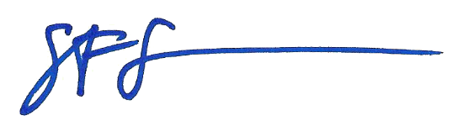
This policy is hereby adopted on this 19th day of March 2019.

_______________________________________
Dr. Steven Siconolfi
Interim Vice President for Academic Affairs

XI. Appendices, References and Related Materials
None.

XII. Revision History
Original Adoption Date: March 19, 2019

