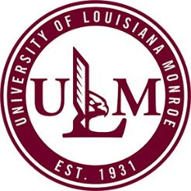
University of Louisiana at Monroe
Department of Human Resources
700 University Avenue
Monroe, LA. 71209-2300

Phone: (318) 342-5140 Fax: (318) 342-5144

NAME AND/OR ADDRESS CHANGE

CWID:
NAME:
NAME CHANGE TO:
Note: To process a name change, the Human Resource office requires originals of the following information: Marriage License or Divorce decree and a Social Security Card. Required copies will be made and originals will be returned to the employee.
OLD ADDRESS:
(Street Address or P.O. Box)
(City, State and Zip Code)
NEW ADDRESS:
(Street Address or P.O. Box)
(City, State and Zip Code)
TELEPHONE NUMBER:
(Include area code)
EMAIL ADDRESS:
I authorize ULM to update and correct my name and address within the Office of Group Benefits, TRSL, LASERS, Starmount Dental and Starmount Vision
SIGNATURE:
(REQUIRED)
PRIVACY REQUEST:
Please do do not release my home phone and /or address information.
DATE:

For Department of Human Resources use only
HRS |  | Insurance |  | ISIS
LASERS |  | TRSL |  | ORP

