

**HIPAA Training Employee Confidentiality Agreement**

Please read the information below and sign at the bottom.

For purposes of this agreement, the word “employee” includes not just employees of ULM, but the entire workforce as defined by the HIPAA Privacy Rules including students, interns, volunteers, staff and graduate assistants.

Individuals receiving healthcare services through ULM have entrusted the staff and have been given the assurance that all information is held in strict confidence in accordance with legal requirements. Any information about a patient’s condition (current or past), care, or treatment must not be discussed with anyone, either at or away from ULM, except with those who are in “need to know” situations according to HIPAA. Carelessness or thoughtlessness leading to the release of this information is not only unethical and possibly illegal, but will be referred to the Privacy Officer for investigation, and possibly the Human Resources Department/Program Director for disciplinary proceedings.

Any breach of a patient’s right to privacy of legally protected health information by an employee of ULM could result in employee disciplinary action, up to and including possible immediate termination and/or dismissal.

**EMPLOYEE ACKNOWLEDGMENT**

I have read the above statement and participated in the corresponding ULM HIPAA Privacy training and I agree to comply with it. I acknowledge that any violation of the ULM HIPAA Privacy policies by me may lead to immediate disciplinary action, up to and including the termination of my employment/dismissal from the program. I also acknowledge that my obligation of confidentiality continues to exist even when I leave the employment or workforce of ULM.

________________________________

Employee Name (printed)

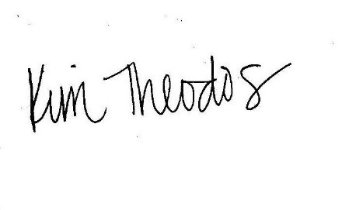________________________________ ___________________________

Employee Signature Date

_______________________________

Privacy Officer’s Signature